The Outer Rings Show 2023
A Show within MAR to Benefit MAR

This show is for CM/AR models only.

Date: March 25, 2023 (During the 1st day of MAR!!)
Show starts at 10:00 am; no arrivals before 8:30 am; unless you are also showing in MAR or volunteered to judge!

Show Hostess: Morgan McGee-Solomon (proptartfan1@yahoo.com)

Show location: Caroline County 4-H & Youth Park, 8230 Detour Road, Denton, MD 21629

NAMHSA Approved
Classes below are open to any CM/AR model and will be run with a charge of $1 per entry per class.

This is a show within a show that will benefit the Mid-Atlantic Regional (MAR) Horse Show which benefits two extraordinary organizations: Enchanted Haven Horse Rescue (EHHR) and Talisman Therapeutic Riding (TTR).

Class entry is $1/horse/class; no limit!!! Remember, this is a benefit. All monies made will go directly to the beneficiaries of MAR.

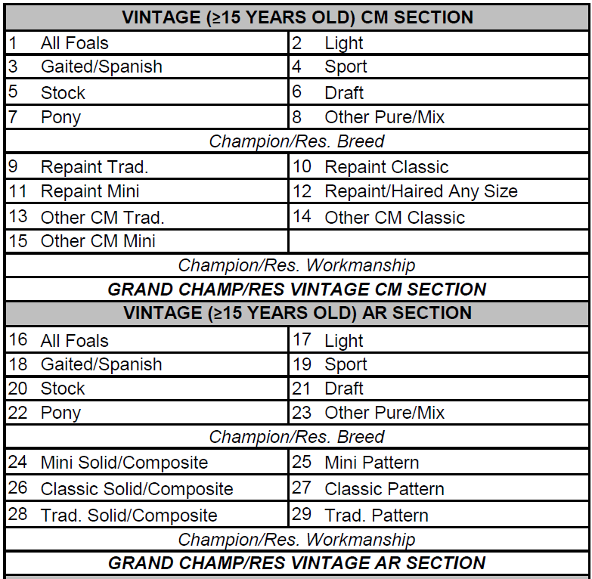

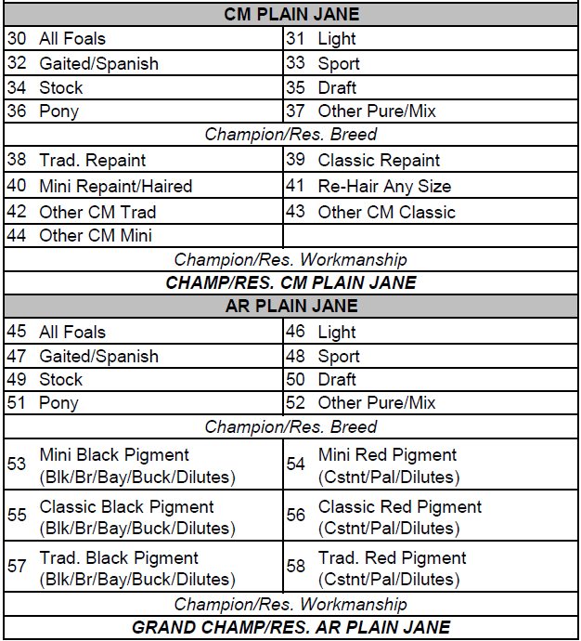

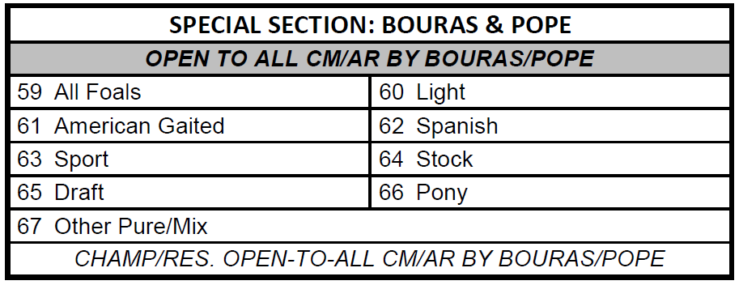

Section Definitions:
- AR/CM Plain Jane Halter Section – open to any size model including foals that have:
1) No dapples.
2) No white markings above the knee/hock or facial white below a line from the corner of the eye to the corner of the mouth; and
3) No roans/brindles/dun factors/appaloosa/pinto patterns.
- Vintage Artist Resin Halter Section – for AR models more than fifteen (15) years old. Restoration is allowed to restore the model to its original state, but no upgrades may be made. Entries MUST include the year the model was completed. Foals and mini-sized models may show here. No Exotics/Etc. they have their own section now!
- Vintage CM Halter Section – Open to CM models more than twelve (12) years old. Restoration is allowed to restore the model to its original state, but no upgrades may be made. Entries MUST include the year the model was completed. Foals and mini-sized models may show here. No Exotics/Etc., they have their own section now!
- Extra Breed Section: Honoring Judy Renee Pope and Elizabeth Bouras’ work. These Sections offer show participants to enter their models in more than one breed class. The $1 charge per model per class still applies. Open to:
  - any AR models sculpted by Liz Bouras and/or Judy Renee Pope and painted by anyone. Must indicate who sculpted and painted the model.
  - any AR models sculpted by any other artist other than Liz Bouras and/or Judy Renee Pope but finished by Liz Bouras and/or Judy Renee Pope. Must indicate who sculpted and painted the model.
  - any mass produced (non-resin) model customized and finished by either Liz Bouras and/or Judy Renee Pope. Must indicate who did the customizing/finishing.

Placings: 1st – 6th, awards will consist of paper ribbons. Quarter and half-sheet paper certificates for champs/grands/reserves. Results will be recorded for 1st and 2nd places only, and results will be emailed to entrants. Please include a SASE if you want paper copies of the results. If approved, models placing 1st or 2nd second will receive NAN cards and be qualified for NAN 2023/2024/2025/2026 and/or be eligible to participate in the merit award program.

Entry fee:
- $5/Entrant Fee for showers entered in CM/AR Day of the 41st Annual MAR 2023. No extra table space is given.
- Sorry, no day-of entry allowed this year. 😭
- Entrants not participating in MAR will be charged $10 entry fee plus the $45 MAR fee for- Half Rectangular Table or $65 for a Full Rectangular Table.
- $45 entry fee for a bring-your-own 3 ft. x 3 ft. table(s) or $60 for a larger table (without a MAR-provided table) [Please let the show holder know if you plan on BYOT].
- Check/MO should be sent and made payable to Morgan McGee-Solomon. PayPal will be accepted if sent as ‘friends and family’: proptartfan1@yahoo.com.
- Entry form/fee received after 3/18/2023 must include an additional $10 late fee.
- Proxy entries are accepted for those who cannot attend - $15 for up to 5 models (no table space is given). Owner must find a proxy person, who can enter the show to show for them.
- REMEMBER: $1 PER MODEL PER CLASS.
  - Place the money down on the table with the model. The model will not be judged if there is not model fee with the horse.
  - Show holder may have some change, but please remember to stop at the bank prior to show day.

If you would like to judge, let the show holder know ASAP. Judges’ perks include early show hall entry; huge gratitude from Morgan; access to judge’s Snack & Water bar, and $5 off your entry fee!!!! Yes, that means no charge for entering the Outer Rings Show if you’ve cross-entered Saturday MAR!!! Winner, winner, 🍗 dinner!

Show Day Organization - multiple tables to save time (think of Anchors Aweigh-style)
Most sections’ breed (AND workmanship, if space allows) classes will be set up for judging at the start of the show. Tables will be earmarked for all sections; all classes within the specified section will load before judging starts. For example, Vintage CM Breed classes will be called up – entrants will bring their models to the designated table and set them down in the area indicated by the class signs. Filling of the rings will start at about 10:00 am.

We’ll take some extra time to fill all the sections/classes before we start the show (or as many as we can). Entrants will be asked to leave their models on the table until all the breed classes for the section are judged – all models in that section will be released at one time. Please do not remove your model(s) until announced by the judges. Red and Green tent cards will be used to indicate whether it is okay to remove models.
- Green tent cards – judging is completed, please remove your models.
- Red tent cards – judging is not completed; please do NOT remove you models.

Once all breed classes are complete, we’ll set up for workmanship in a similar manner. This should make it easier on everyone, especially those who have offered to judge in both Shows, as it will allow them to set out their models.

For planning purposes, I am asking that entrants approximate their entries per section. The table for approximate entry numbers is located on the show form. Thank you!

Tags: Each shower must provide a tag with the model’s name and your initials on one side, and the model’s breed, gender, and age on the other. Remember: place the breed, gender, age side up of the tag for judging. Failure to do so will be cause for disqualification.

Tack: No tack on the model please (unless it’s molded onto the model). These are halter divisions; the models must be naked.

No Holds: There are two shows happening at once and to keep both shows moving, judging will not stop.

Disclaimer
Morgan and other Show judges and the show committee may not be held responsible for any lost, broken, or missing property or injury to any participants. Enter and bring yourself and your models at your own risk. Entry into the show means you accept this. If you bring anyone extra (spouse, parent, friend, etc.) they must abide by these terms as well. There are no refunds once your entry has been received.

Directions: Please check MapQuest, Google maps, Bing Maps, etc. or email for directions. GPS directions generally works well.

Lunch/Food: Outside food is permitted! There will be a lunch break – probably starting around 12:30 pm for 1 hour (During which time the MAR color challenge classes will be held). There are a few fast-food places within a short drive from the hall: Subway, Domino’s Pizza, Arby’s, McDonalds, Taco Bell, etc.

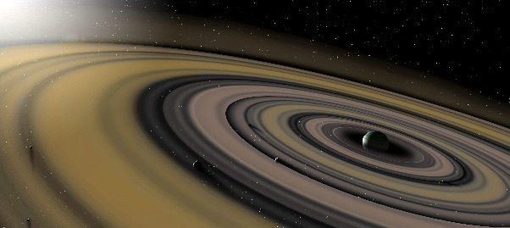
Entry Form – The Outer Rings Show 2023

Mail to: Morgan McGee-Solomon
31 West 38th Street
Wilmington, Delaware 19802

Or email to: proptartfan1@yahoo.com

Name:
 | First Name | Last Name
Full Mailing Address:
 | Street Address, Suite/Apt. No, City, State, ZIP Code
Email Address:
Phone Number | ( )

Check one: ☐ I am willing to judge, please subtract $5 from my entry fee.
I would like to judge the following division(s) (check the division(s)):
☐Vintage CM ☐Vintage AR ☐CM Plain Jane ☐AR Plain Jane
☐ I am not showing at MARs and need a (check one):
☐ Half Table ($45) or ☐ Full Table ($65) or ☐BYOT

☐ This is a proxy entry ($15 for 5 horses).
Who will be showing your models? Name of Proxy: _________________

Approximate number of models you plan to show in each section – MUST be received by 3/18/2023 – this helps with planning!
Vintage | Approx. Number of Models | Plain Jane | Approx. Number of Models | Extra Breed Sections | Approx. Number of Models
CM Breed |  |  |  | Vintage CM/AR by Bouras/Pope
CM Workmanship
AR Breed |  |  |  | Plain Jane CM/AR by Bouras/Pope
AR Workmanship

Entry Fee Total: $_____________

I, (print name) ____________________________ have read and understand the rules of this show and agree to abide by them, as well as the decisions of the judges and show manager/committee. I understand that if these rules are violated, I may be asked to leave the show with no return of fees paid. By signing this form and attending the Outer Rings Model Horse Show, I hereby agree to these terms, and release the aforementioned show, show manager, show committee, judges, volunteers, sponsors and the Caroline County 4-H & Youth Park from liability for loss, damages or injury to any person or property which may occur during the show activities. I also acknowledge that I rightfully own all the models I am showing and am not showing models for another person/relative unless I am paying the appropriate proxy fee, or that person is present and judging.

Signature (if under 18, parent or guardian must sign & print name | Date

